**Experiment 5**

**Student Name:** Sahil Kaundal **UID:** 21BCS8197

**Branch:** BE CSE (Lateral Entry) **Section/Group:** 807/B

**Semester:** 4th **Date of Performance:** 29/03/2022

**Subject Name:** MPI Lab **Subject Code:** 22E-20CSP-253

1. **Aim/Overview of the practical:**

Complement of a number 16 bit data.

**2. Task to be done/ Which logistics used:**

1’s Complement of a number 16 bit data using Jubin Application.

2’s Complement of a number 16 bit data using Jubin Application.

**3. Apparatus / Simulator Used:**

1. Jubin Application

2. 8085 Simulator

3. JDK

**4. Algorithms:**

**1’s Complement:**

1. Load H – L pair with address 1000H.

2. Complement Accumulator.

3. Store the result at memory location 1050H.

4. Terminate the program.

**2’s Complement:**

1. Load H – L pair with address 1000H.

2. Complement Accumulator.

3. Store the result at memory location 1050H.

4. Increase Accumulator by 1.

5. Store the memory location 1051H.

6. Terminate the program.

**5. Programs:**

**1’s Complement:**

LHLD 300H

MOV A, L

CMA

MOV L, A

MOV A, H

CMA

MOV H, A

SHLD 3002H

HLT

**2’s Complement:**

LHLD 300H

MOV A, L

CMA

MOV L, A

MOV A, H

CMA

MOV H, A

INX H

SHLD 3002H

HLT

**6. Result/Output/Writing Summary:**

**1’s Complement:**

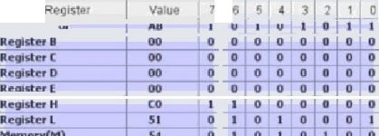

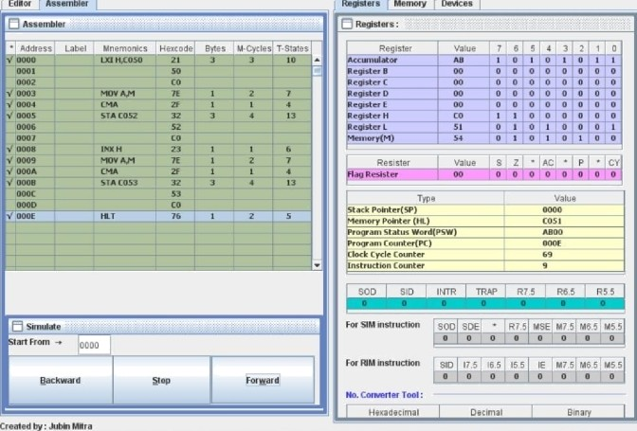

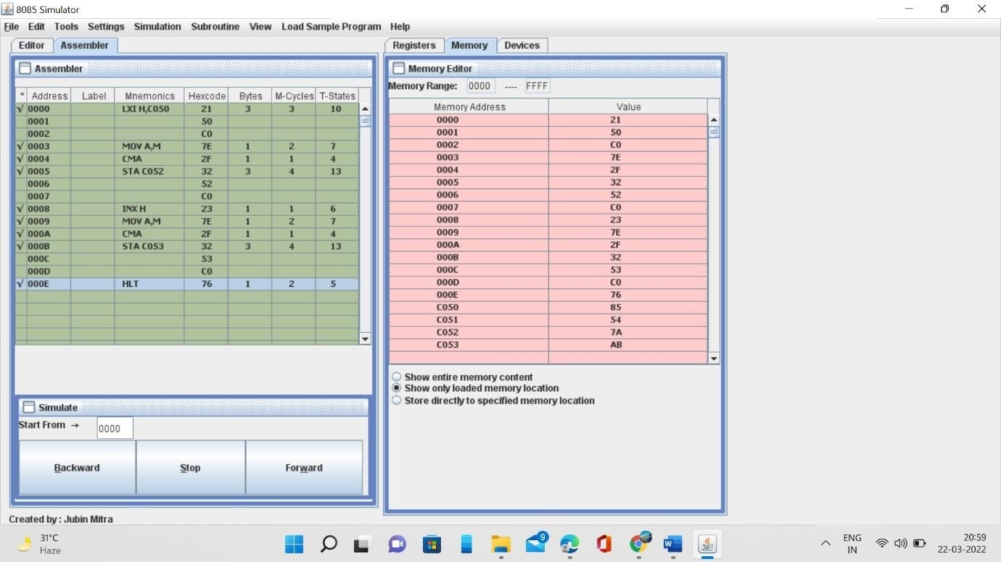

**2’s Complement:**

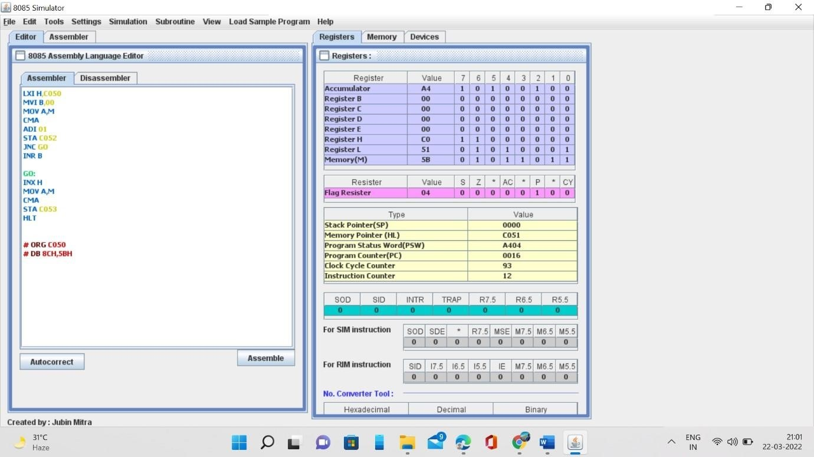

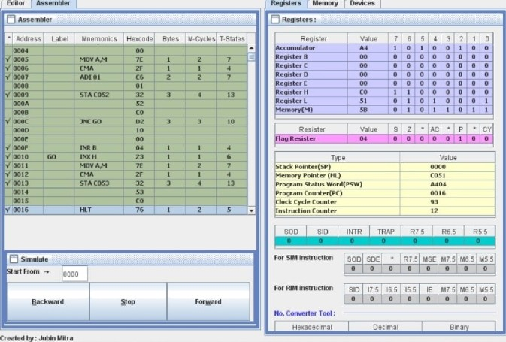

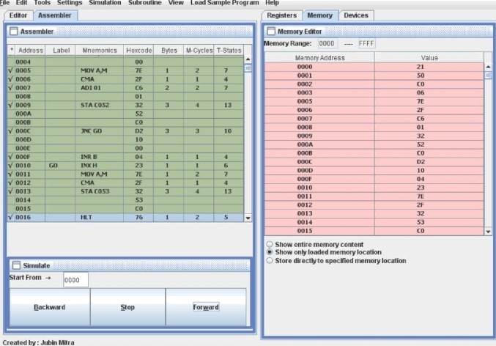a x

**Learning outcomes (What I have learnt):**

1. Working of microprocessors.

2. Learn how to complement data in microprocessors.

3. Operations of 16 bit numbers.

4. Learn about the different instructions that are needed to be given to the memory to perform some tasks.

**Evaluation Grid (To be created as per the SOP and Assessment guidelines by the faculty):**

|  |  |  |  |
| --- | --- | --- | --- |
| Sr. No. | Parameters | Marks Obtained | Maximum Marks |
| 1. |  |  |  |
| 2. |  |  |  |
| 3. |  |  |  |
|  |  |  |  |